

**Faculty of Engineering & Applied Science**

**Experiment Name:** **Connecting IoT devices using BT wireless and Arduino Programming**

**Experiment date: 10/05/2022**

**Group Number*: 4***

**Section CRN: 44432**

**Course Instructor: *Ramiro Liscano***

**Lab TA:*****Sifatul Mostafi***

| **Student Name** | **Student Id** |
| --- | --- |
| Preet Patel | *100708239* |
| Tiwaloluwa Ojo | *100700622* |
| Waleed El Alawi | *100764573* |

## **Learning Objectives**

The objective of this lab was to learn how to setup a bluetooth connection between the Raspberry Pi and a device. We learned how to setup bluetooth on a device using the Arduino UNO R3 board and the DSD HC-05 bluetooth module. In this lab, we also learned how to create a C program to get readings from a DHT11 temperature and humidity sensor connected to the arduino board.

**Deliverables:**

**Bluetooth Communication Activity:**

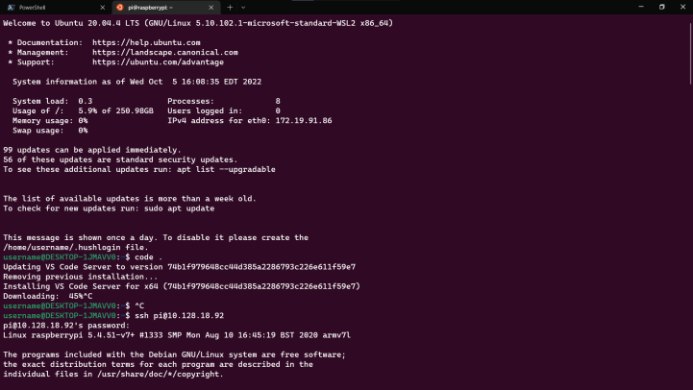

*SSH into the Raspberry Pi*

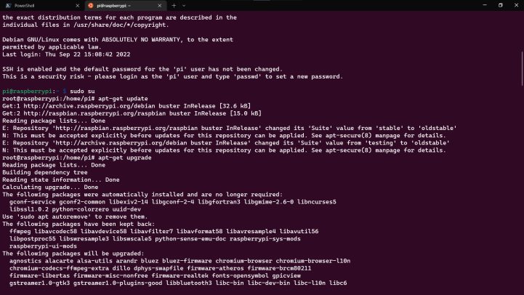

*Registered ourselves as a Super User. This allows us to execute commands as an Administrator*

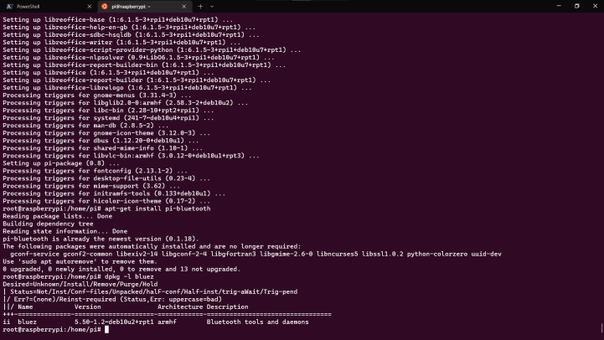

*Fetched and installed the latest packages from the distribution repository. We also installed PI-Bluetooth and verified its installation*

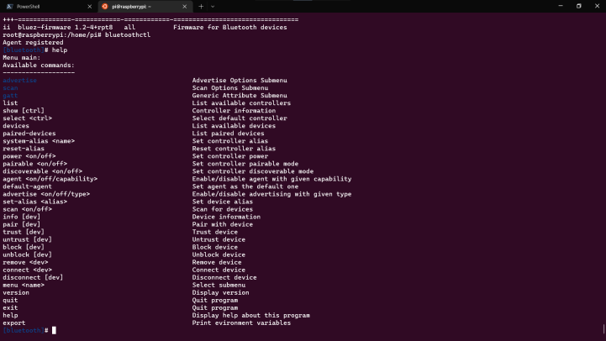

*Engaged the CLI tool that would allow us to scan, pair and connect to our Arduino bluetooth module*

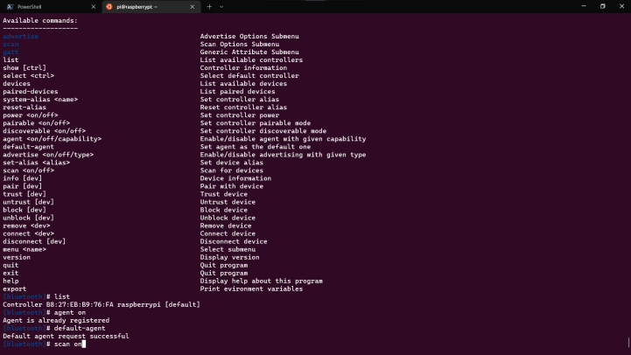

*Acknowledged the controller agent is registered and operational before scanning for devices*

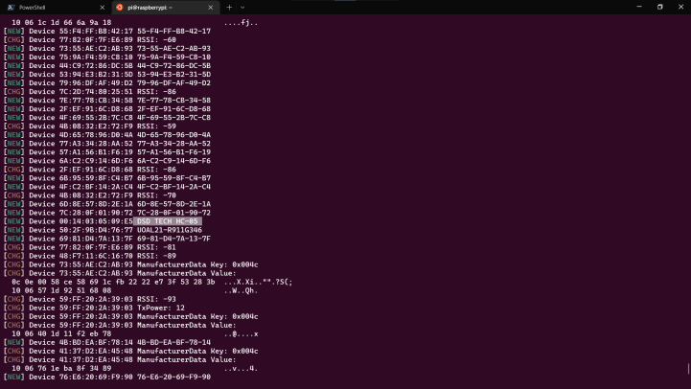

*Scanned for our Arduino Uno BLE module and extracted its MAC Address. It was identified as* ***DSD TECH HC-05****.*

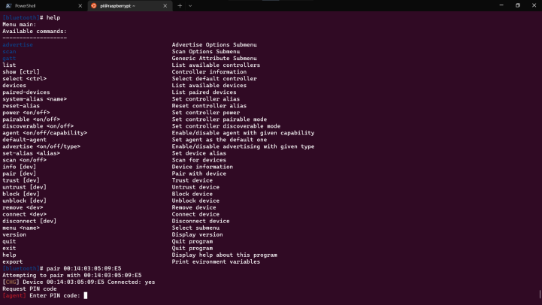

*Upon pairing with the module we were queried for its PIN Code which was* ***1234 or 0000***

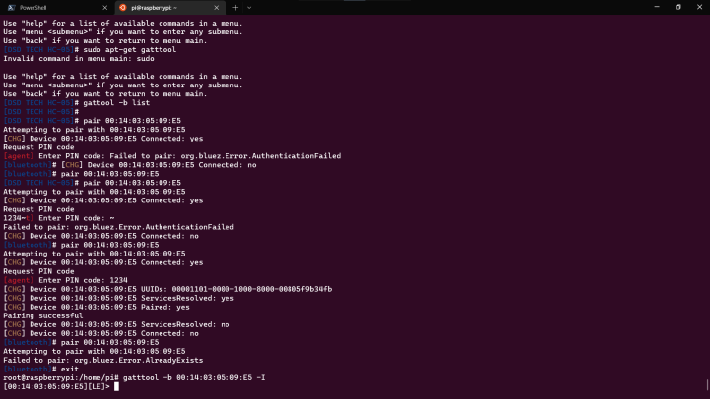

*Though we were able to successfully pair with the device we were not able to connect, therefore denying us the ability to get the* ***characteristics*** *of the device.*

## Arduino Programming Temperature and Humidity Sensor:

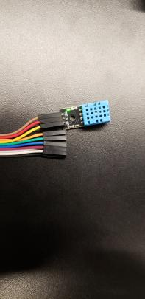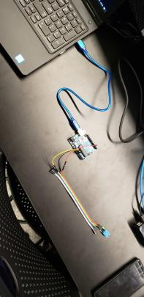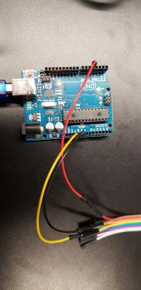

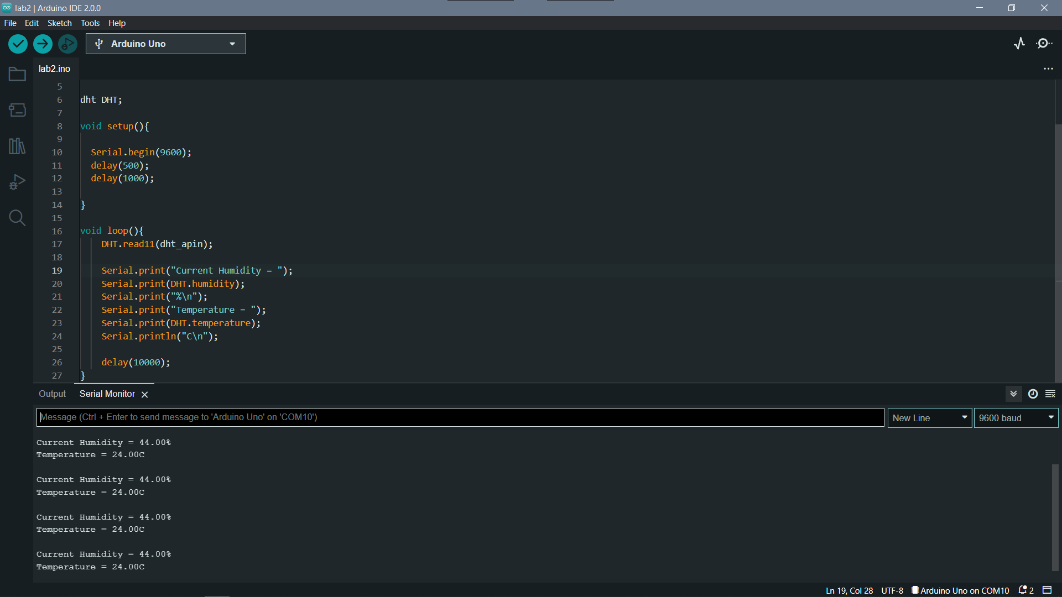

*Temperature and Humidity Sensor Setup and Program output reading room temperature and humidity*

### 

### Source Code:

#include <dht.h>

#define dht_apin A4 // Analog Pin

dht DHT;

void setup(){

Serial.begin(9600);

delay(500);

delay(1000);

}

void loop(){

DHT.read11(dht_apin);

Serial.print("Current Humidity = ");

Serial.print(DHT.humidity);

Serial.print("%\n");

Serial.print("Temperature = ");

Serial.print(DHT.temperature);

Serial.println("C\n");

delay(10000);

}

**How does the above source code work?**

In order to write a program capable of reading the temperature and humidity from the DHT 11 sensor, we used the dht C library which comes with functions which can be used to interact with the DHT 11 Temperature and Humidity Sensor. We connected the data pin of the sensor with the A4 analog pin on the Arduino UNO R3 board to transfer data between the sensor and the board. We create a variable called dht_apin to store the analog pin, and create a dht object called DHT which will be used to read the temperature from the sensor. For the setup function, we begin and delay to wait for the system to boot and delay again before accessing the DHT 11 sensor. In the loop function, we start by reading the data incoming from the sensor using the read11 function of the DHT object and pass the analog pin as a parameter to the function. This function will read all the temperature and humidity from the sensor and store in temperature and humidity variables of the DHT object. In order to print the output, we use Serial.print and first we print the humidity and then the temperature. We also added a delay of 10000 to let the program wait 10 seconds before it accesses the sensor for another reading.